Assignment -1

|  |  |
| --- | --- |
| Assignment Date | 21 September 2022 |
| Student Name | Aruna R |
| Student Roll Number | 713319CS013 |
| Maximum Marks | 2 Marks |

Question-1:

Build a smart home in Tinkercad with 2 sensors, an Led, buzzer and submit

it **Solution :**

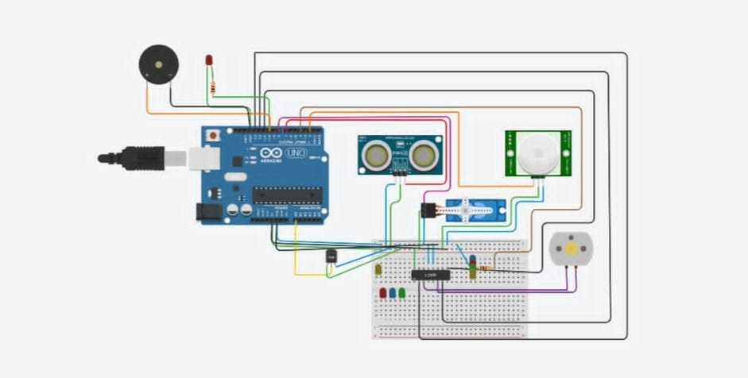

#include<Servo.h> const int pingPin = 7; int servoPin = 8;

Servo servo1;

void setup() {

Serial.begin(9600); servo1.attach(servoPin);

pinMode(2,INPUT); pinMode(4,OUTPUT); pinMode(11,OUTPUT); pinMode(12,OUTPUT); pinMode(13,OUTPUT); pinMode(A0,INPUT); digitalWrite(2,LOW); digitalWrite(11,HIGH); pinMode(2, INPUT); pinMode(10,OUTPUT);

}

void loop() {

long duration, inches, cm;

pinMode(pingPin, OUTPUT); digitalWrite(pingPin, LOW); delayMicroseconds(2); digitalWrite(pingPin, HIGH); delayMicroseconds(5); digitalWrite(pingPin, LOW);

pinMode(pingPin, INPUT); duration = pulseIn(pingPin, HIGH);

inches = microsecondsToInches(duration); cm = microsecondsToCentimeters(duration);

servo1.write(0);

if(cm < 40)

{

servo1.write(90); delay(2000);

}

else

{

servo1.write(0);

}

int pir = digitalRead(2); if(pir == HIGH)

{

digitalWrite(4,HIGH); delay(1000);

}

else if(pir == LOW)

{

digitalWrite(4,LOW);

}

Serial.println(digitalRead(2)); if (digitalRead(2) == 1) { digitalWrite(10, HIGH); } else

{

digitalWrite(10, LOW);

}

delay(10);

float value=analogRead(A0); float temperature=value*0.48;

Serial.println("temperature"); Serial.println(temperature);

if(temperature > 20)

{

digitalWrite(12,HIGH); digitalWrite(13,LOW);

}

else

{

digitalWrite(12,LOW); digitalWrite(13,LOW);

}

}

long microsecondsToInches(long microseconds) { return microseconds / 74 / 2;

}

long microsecondsToCentimeters(long microseconds) { return microseconds / 29 / 2;

}